

MATLAB-EXPERIMENT 5b

Line integral and work done



APRIL 9, 2021

BIMAL PARAJULI

20BDS0405

Department of Mathematics

School of Advanced Sciences

MAT 1011 – Calculus for Engineers (MATLAB)

Experiment 5-B

Line integral and work done

Prepared by: Bimal parajuli

Registration Number: 20BDS0405

1. **1) Find the work done for the force 𝐹⃗(x,y,z)= yz𝑖⃗ + xz 𝑗⃗ + (xy+2z) 𝑘⃗⃗ along the line segment from (1,0,-2) to (4,6,3).**

**CODE:**

% Find the work done for the force f(x,y,z)= yz i + xz j + (xy+2z)k along the line segment from (1,0,-2) to (4,6,3).

clear;

close all;

clc;

syms x y z t;

func = [y*z, x*z, (x*y+2*z)];

disp("The given function = ");

disp(func);

pointa = [1, 0, -2];

pointb = [4, 6, 3];

disp("The given points of line segment = ");

disp(pointa);

disp(pointb);

par = pointa .* (1 - t) + pointb .* t;

disp("Parametric equations are = "); disp(par);

interval = [0,1];

a = interval(1);

b = interval(2);

dpar = diff(par, t);

F = subs(func, {x, y, z}, par);

Fdpar = sum(F .* dpar);

integral = int(Fdpar, t, a, b);

disp("Work done by the force F = ");

disp(integral);

fx(x, y, z) = func(1);

fy(x, y, z) = func(2);

fz(x, y, z) = func(3);

[xcords, ycords, zcords] = meshgrid(linspace(-4, 4, 10));

U = fx(xcords, ycords, zcords);

V = fy(xcords, ycords, zcords);

W = fz(xcords, ycords, zcords);

figure(1);

quiver3(xcords, ycords, zcords, U, V, W);

hold on;

grid on;

tvals = linspace(0, 1, 10);

x1 = subs(par(1), tvals); y1 = subs(par(2), tvals); z1 = subs(par(3), tvals);

plot3(x1, y1, z1, 'r');

xlabel("X-axis");

ylabel("Y-axis");

zlabel("Z-axis");

hold off;

**OUTPUT:**

The given function =   
[y*z, x*z, 2*z + x*y]  
   
The given points of line segment =   
 1 0 -2  
  
 4 6 3  
  
Parametric equations are =   
[3*t + 1, 6*t, 5*t - 2]

Work done by the force F =   
77

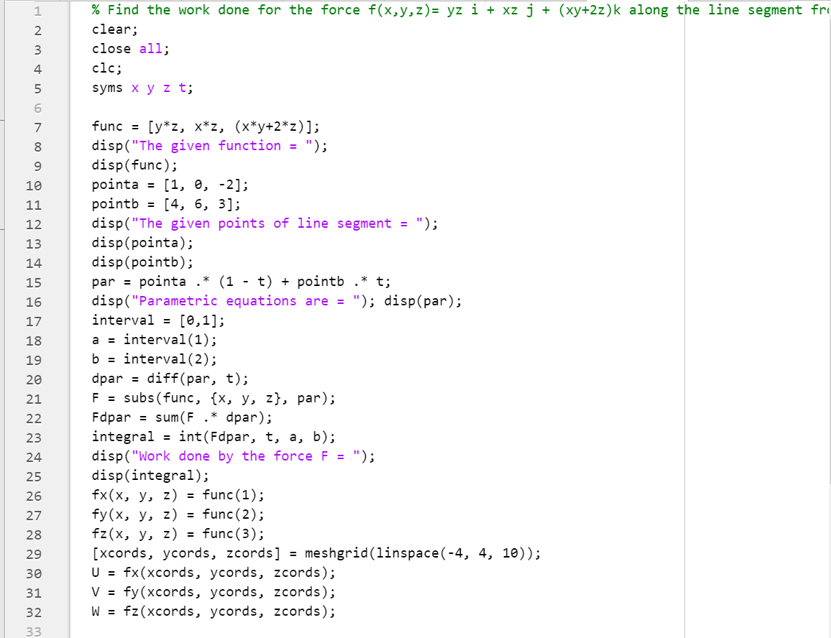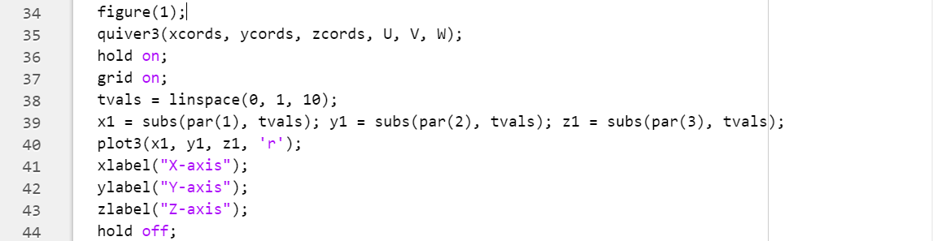

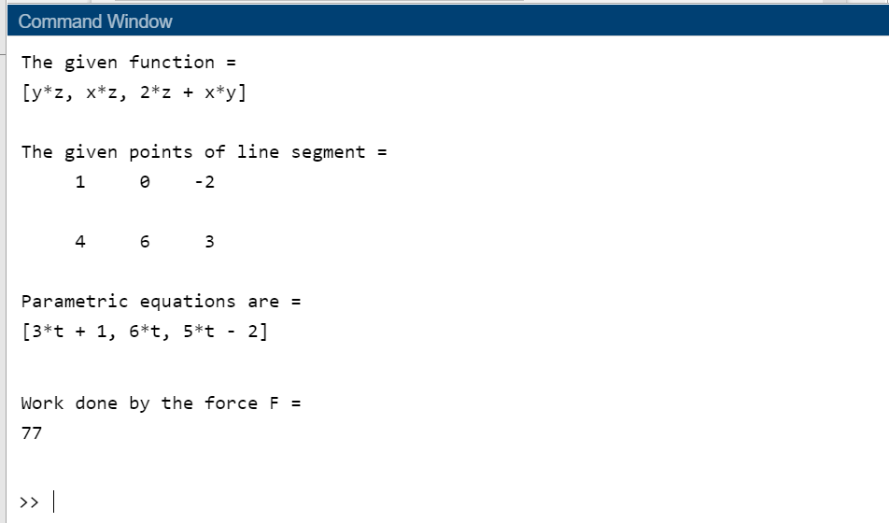

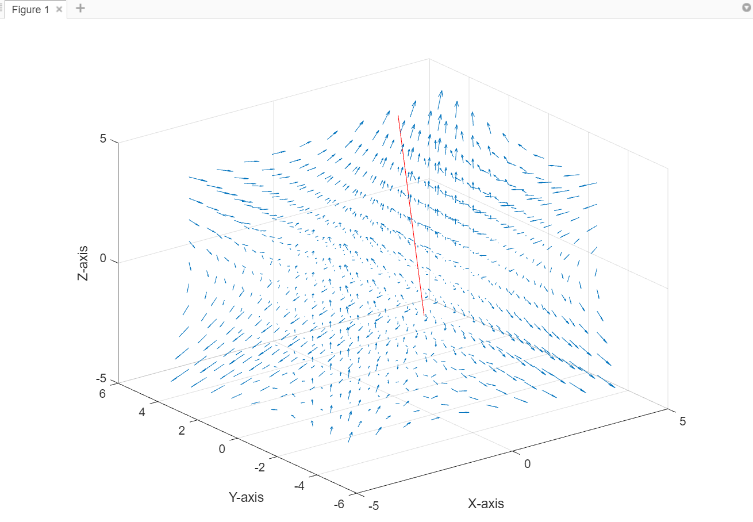

1. **Find the work done for the force 𝐹⃗(x,y,)= x2 𝑖⃗ + y2 𝑗⃗ along the arc of the parabola y =2x2 from (-1,2) to (2,8).**

**CODES:**

% Find the work done for the force f(x,y,z)= yz i + xz j + (xy+2z) k along the line segment from (0,0,2) to (4,6,3).

clear;

close all;

clc;

syms x y z t;

func = [y*z, x*z, (x*y+2*z)];

disp("The given function = ");

disp(func);

pointa = [0, 0, 0];

pointb = [4, 6, 3];

disp("The given points of line segment = ");

disp(pointa);

disp(pointb);

par = pointa .* (1 - t) + pointb .* t;

disp("Parametric equations are = "); disp(par);

interval = [0,1];

a = interval(1);

b = interval(2);

dpar = diff(par, t);

F = subs(func, {x, y, z}, par);

Fdpar = sum(F .* dpar);

integral = int(Fdpar, t, a, b);

disp("Work done by the force F = ");

disp(integral);

fx(x, y, z) = func(1);

fy(x, y, z) = func(2);

fz(x, y, z) = func(3);

[xcords, ycords, zcords] = meshgrid(linspace(-4, 4, 10));A

U = fx(xcords, ycords, zcords);

V = fy(xcords, ycords, zcords);

W = fz(xcords, ycords, zcords);

figure(1);

quiver3(xcords, ycords, zcords, U, V, W);

hold on;

grid on;

tvals = linspace(0, 1, 10);x1 = subs(par(1), tvals); y1 = subs(par(2), tvals); z1 = subs(par(3), tvals);

plot3(x1, y1, z1, 'r');

xlabel("X-axis");

ylabel("Y-axis");

zlabel("Z-axis");

hold off;

**OUTPUT:**

The given function =   
[y*z, x*z, 2*z + x*y]  
   
The given points of line segment =   
 0 0 0  
  
 4 6 3  
  
Parametric equations are =   
[4*t, 6*t, 3*t]  
   
Work done by the force F =   
81

